**Performance Analysis (Accuracy)**

The accuracy using SVM is 89.5%.

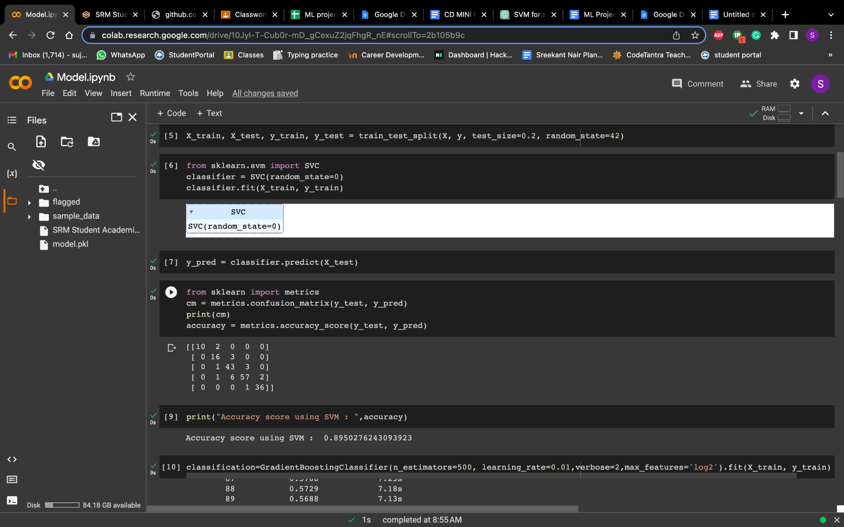

The accuracy using gradient boost is 92.8%.

